
Boronia Park Public School
Newsletter
Email: boroniapk-p.school@det.nsw.edu.au Website: www.boroniapk-p.schools.nsw.edu.au

Term 3 Week 7 29 August 2022

WEEK'S EVENTS
Tuesday 30 Aug | Festival Of Instrumental Music - Banksia Concert – selected students
Wednesday 31 Aug | Stage 3 Gold Discovery excursion (Group 3)
Thursday 1 Sept | Recorder group at morning assembly
Friday 2 Sept | Fathers’ Day BBQ
COMING EVENTS
Monday 5 Sept | Compass Parent Session – 5:30pm

PRINCIPAL’S REPORT

As we head into Week 7 of this term, a reminder yet again that we are still receiving reports of COVID within our school community. If your child is unwell or displaying any flu-like symptoms, please do not send them to school. If your child is a household contact to a positive case of COVID-19, and they are not presenting with any symptoms, they are required to take a RAT test daily and if possible, wear a mask to school. Whilst masks remain not compulsory, they are highly recommended. Ventilation remains a priority within our school, and all events will be run in a COVID safe manner.

Congratulations to our Zone athletics carnival representatives who performed so well last Thursday at Sydney Olympic Park. I am very pleased to hear we have several students who will be moving on to represent the Ryde district at the Regional carnival on Monday 19 September. Good luck to you all!

Thank you to all the Year 4 parents who attended the Earthkeepers parent information evening last Monday night. We were most pleased with the strong turnout. Thank you also to Miss Scott, Mrs Butler and Miss Tracey who presented on the evening. If any parents have any further questions, please do not hesitate to contact your child’s class teacher.

I enjoyed meeting many of our new parents at our Information Evening last Tuesday night. Thank you to our student leaders, school choir, Flynn P and Juliette K who all presented so beautifully on the evening. I look forward to getting to know our new parents further in the future and ensuring a smooth transition for our 2023 Kindergarten cohort.

I was delighted to get a late message yesterday afternoon letting me know that our Performance Band achieved Gold at the Australian Schools Band and Orchestra Festival, held at the University of NSW on Sunday. This result does not occur without a lot of time and effort that is put in behind the scenes, so congratulations to our students, conductor Mike and Mrs Nylund, coordinator of our music program, for this outstanding result.
Finally, I hope many of you take the opportunity to attend the P&Cs Fathers’ Day breakfast this Friday morning. I know it will be a wonderful event. Also, I would like to wish all our dads a very happy Father’s Day for this upcoming Sunday. I hope you have a wonderful time celebrating the special role you all play in your children’s lives.

Mrs Ward

DEPUTY PRINCIPAL’S REPORT

Next Monday, 5 September at 5:30pm we have a Compass Parent information session to help you get the most out of Compass and troubleshoot any issues you’re having with the app. You will also be shown how to easily add attendance notes via the app to make sure absent notes are always on time.

Education for your child is important and regular attendance at school is essential for your child to achieve their educational best and increase their career and life options. NSW public schools work in partnership with parents to encourage and support regular attendance of children and young people. When your child attends school every day, learning becomes easier and your child will build and maintain friendships with other children.

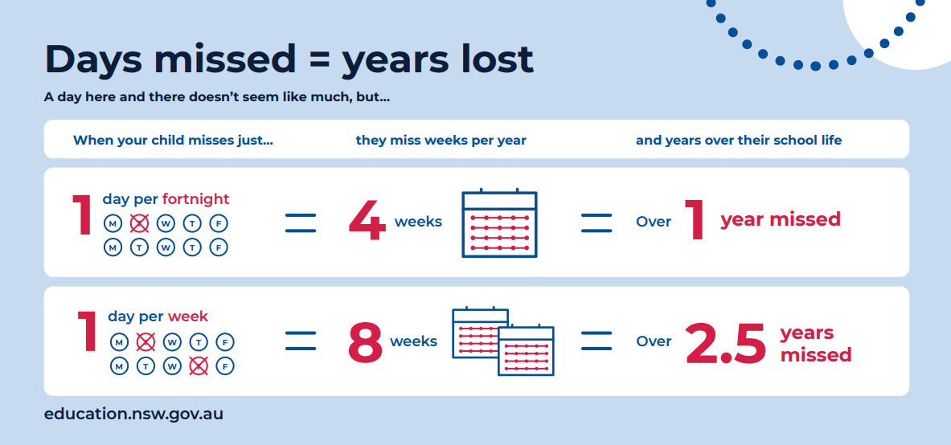

Mrs Taylor

OFFICE REPORT

HOW TO SEND AN EMAIL TO YOUR CHILD’S TEACHER
Go to the bottom of the phone and tap on 3 lines (more)
Tap on open in browser
Tap on send an email
You will now be able to email teacher

NB. The teacher’s reply will go through to your email and not through the Compass app.
ie. You will need to open your emails in your browser.

REMINDER: The school no longer supports School ENews. Please use the Compass portal for all school communications.

AWARDS

Congratulations to the following students for receiving their Gold Awards:

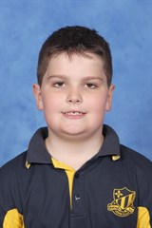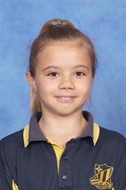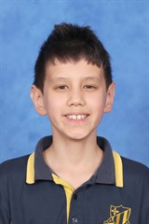
Otis VD 3T Lexi H 6C Jacob D 5A

COMPASS PARENT PORTAL
INFORMATION EVENING

Learn how to use the Compass portal and app. A representative from Compass will be available to answer any questions you have.

The Compass Parent Portal is an online portal that allows you to access up-to-date information about our school.

When: Monday 5 September 2022
Time: 5:30-6:30pm
Venue: 6S classroom

Ms Reynolds

CREATIVE ARTS

Ensemble rehearsals are on as usual this week.

GOLD FOR PERFORMANCE BAND! 🥇
Congratulations to our dedicated Performance Band who participated in the Australian Schools Band and Orchestra Festival held at The University of New South Wales on Sunday and were awarded GOLD in the senior band event! A magnificent achievement and a wonderful reward for all their hard work.

Huge thanks to our fantastic conductor Mike Rix for his brilliant work preparing the band, and special thanks to Kirsty Hales for all her detailed organisation and much-valued commitment to the program. A big thank you also to Mrs Hunt for her assistance on the day and of course to all our parents who support the program and their children’s involvement. We are very proud of every student in the band for the effort they put in each week, and on this wonderful result.

JUNIOR CHOIR
Congratulations to the junior choir on a lovely performance at the new parents Information Evening last Tuesday. I was very proud of all the students who performed beautifully.

SENIOR CHOIR
A reminder that the next rehearsal for the Ryde Schools’ Spectacular is Thursday 8 September. All senior choir students will be attending as per the permission note. This is our final combined choir rehearsal before the dress rehearsal at the Opera House on Friday 23 September.

FESTIVAL OF INSTRUMENTAL MUSIC
Best wishes to our Festival Recorder Group (Maisie H, Leah H, Katrina Y, Sienna P and Maeve K) who are performing at the Opera House on Tuesday evening in the Festival Of Instrumental Music. This is wonderful performance experience and we know they will do our school proud. Many thanks to Jackie Brighton for all her hard work with the students.

RECORDER – RED AND PURPLE GROUPS
Red Group at 8:45am on Wednesday

Purple Group at 8:45am on Thursday (and optional for Purple group to attend Wednesday rehearsal as well)

COMBINED PERFORMANCE for Red and Purple groups at morning assembly under the COLA 9:20am on Thursday 1 September (parents, relatives and friends welcome to attend).

FESTIVAL RECORDER GROUP
The Festival recorder group will be attending the final rehearsal and Banksia concert at the Opera House this Tuesday 30 August. We wish them all the best for their special performance.

The Festival group will be performing at the year 3-6 assembly, 10:30am on Friday 2 September. Parents, relatives and friends welcome to attend.

Jackie will be away from 5 September so no recorder groups or private music lessons for the rest of the term. Group lessons and private lessons recommence in Week 1 of Term 4.

Mrs Nylund

GRANDPARENTS’ MORNING TEA


** SAVE THE DATE **
Grandparents’ Morning at
Boronia Park Public School
Wednesday 2 November

LIBRARY


Student access to the Premier’s Reading Challenge has now closed. Congratulations to the 503 students who have completed this year’s challenge, and the following students on completing their Challenge last week:

Harriet H, Jasmine L, Layla P, Lucia T, Samar C 1LP, Haydn R, Oscar C, Samuel G, Sophia K, Timeo H 1M, Frankie G, Jaslynn G, Nina K, Oliver C, Sebastian W, Sylvester T, Tuan N 2L, Allison M, Amba B, Harrison T, Jack B, Olivia M, Tilly S, Violet O 2P, Aurora G, Emily M, Owen D 3G, Addison A, Airlie R, Bronte P, Declan L, Eli P, Lillian R, Lloyd R, Max K 3T, Amelie S, Angie N, Isla S, Marianna L, Mia K 4S, Deacon W 5A, Aiden P 5K, Aayan C, Cassius H, Luca I, Rebekah V, Xavier R 6C.

Mrs Hunt

The library is a great place to visit. You can see the new paintings, borrow books, play games, do a colouring for Peter Rabbit and read books. On Thursday the library loaned out 103 books. It is lots of fun.
By Juliette K, Gabrielle K and Marc K

SMILE CONERT - TICKETS

Tickets for the Smile Concert are available for purchase online through Trybookings from today.

The cost of the tickets is $25/ticket.

Please note that only 2 tickets per family are available between Monday 29 August and Thursday 8 September. After this date, the site will open up to allow additional tickets per family.

There will be three concerts at 10:00am, 12:30pm and 6:30pm. Please carefully select the time you would like to attend. There is no facility for change of mind.

Tickets are not numbered - Parents will be allocated a seat on the day as they enter the COLA area.

Note – the saving of seats for people who have not yet arrived will not be an option on the day.

SPORT


ZONE ATHLETICS CARNIVAL
Congratulations to all competitors who took part in the Ryde Zone Athletics Carnival last Thursday. Well done to the students who will compete at the Sydney North Carnival on Monday 9 September.

WINTER PSSA SEMI-FINALS
There is NO training this Friday 2 September due to the Father’s Day breakfast.

Congratulations to all who will all take part in semi-final matches. Further details of finals will be finalised in the next few days. All teams will still take part in friendly matches.

Mr Smyth

P&C

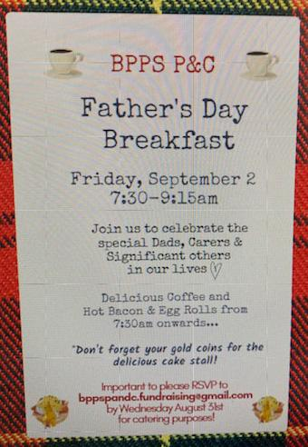

We look forward to celebrating all the dads, father figures and significant others in our lives, this Friday 2 September, before school starts. Join us for a coffee, bacon and egg roll, some baked treats and some social time as we celebrate all the important people in our lives! Please RSVP by Thursday 1 September to Jess Collins at bpps.fundraising@gmail.com, and if you would like to help out on the BBQ or cake stall, please sign up at https://signup.com/go/oefCtXJ

FATHERS’ DAY GIFTS
We hope you enjoy the gifts that go home this week - we hear that the children have been excited about creating their artworks for the significant people in their lives. We also hope you all have a wonderful weekend celebrating the important people in your lives - let's hope the rain stays away!

THANK YOU TEACHERS!
I would like to give a shout out to the teachers who have helped create the gifts for Fathers’ Day. They have been supporting their students through the process and without them this would have been a difficult task. Ms Marriot has also been driving this initiative and the P&C is very grateful for her help and efforts in helping to make it succeed, including matching it to the school curriculum!

ANNUAL SPRING HIGH TEA – 10 SEPTEMBER
With only 2 weeks to go till the High Tea, make sure you get your tickets via Flexischools. You can buy any extra tickets on behalf of friends or family who do not have access to online ticket sales.

A very popular part of the High Tea each year is seeing the very talented readers. We have an Express Lane this year to see Denise the Angel Reader or Katie the Tarot Card Reader, jumping the queue! It's a $50 donation to jump the queue and you also will get a slightly longer reading. If you wish to guarantee your spot, it is only available for the first 3 people for each reader, please email samantha@thevc.com.au There are only usually 13 spots available per reader for the day.

We are still sourcing auction and raffle prizes, so if you know anyone who may be willing to donate a voucher from their business or a product, please email Clare Hollings tomandclare@internode.on.net It's not only appreciated as it helps us raise money for the school, it's a great way to showcase their business to the community. We are happy to display business cards and promotional material at the event too.

Any keen helpers for the event, either in lead up or on the day let us know. We only roster you for about 15 minutes if you help on the day so you won't miss much of the event! samantha@thevc.com.au

BPPS P&C Fundraising & Events Team

CANTEEN

Mondays: Sushi $3.70
Tuesdays: Roast chicken rolls $5.00
Salad boxes with chicken $5.50

Wednesdays: Chicken and beef burgers

Thursdays: Sushi $3.70


BUSY CANTEEN – HELP DESPERATELY NEEDED
This Photo by Unknown Author is licensed under CC BY

The canteen continues to get busier and we need your help!

The new roster for Term 3 is now open. Along with our usual shifts, we’ve introduced new half day shifts on Thursdays and Fridays to help manage the lunch time rush. There are also Friday afternoon iceblock sales shifts available.

To make it easier for our volunteers the canteen roster is now online. If you know you have a free day coming up, jump online and add yourself to the roster.

The roster can be found at or by scanning the QR code: https://signup.com/go/huwfTkq




FRIDAY AFTERNOONS

The canteen is open on Friday afternoons from 3:20pm. Come by to get your end of week treats.

FRESH 4 KIDS – EAT FRESH & WIN 2022

The Eat Fresh and Win campaign is back for 2022. Commencing Monday 1 August and ending Friday 16 September 2022, each time a student makes a healthy selection from the canteen (fruit and/or vegetables), they are rewarded with a stamp on their entry form. Collect 2 stamps and you will receive a minor prize and go into the major prize draw.

SAUSAGE SIZZLE 23 SEPTEMBER


Our end of term sausage sizzle will be on Friday 23 September. Orders can be placed via Flexischools or paper order forms are available from the canteen. Order now or before Tuesday 20 September.

required please.

SAUSAGE SIZZLE
Friday 23 Sept 2022
ORDER FORM
Celebrate the end of the term with a freshly cooked sausage on bread roll with tomato or BBQ sauce for $4. Add a drink for $2.00.
All orders must be received by 10am Tues 20 Sept 2022. **No orders will be taken on the day**

Child’sName ________________________________
Class: _____________
□ Sausage Sizzle $4.00
□ Glee/juice,/straw milk/choc milk/water $2.00
(Please circle your drink choice)


