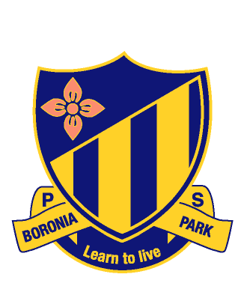
Boronia Park Public School
Newsletter
Email: boroniapk-p.school@det.nsw.edu.au Website: www.boroniapk-p.schools.nsw.edu.au

Term 3 Week 3 1 August 2022

WEEK'S EVENTS
Monday 1 August | P&C General meeting – 7:30pm in Library or via Zoom
Tuesday 2 August | NSW Premier’s Spelling Bee School Finals (Stage 2 and 3)
Tuesday 2 August | Boronia Thunder vs Boronia Lightening Debate
Wednesday 3 August | Ryde Spectacular Drama Rehearsal – selected students
Thursday 4 August | Ryde Spectacular Choir Rehearsal – selected students
COMING EVENTS
Monday 8 August | School Athletics Carnival – (K-6) Dunbar Park, Marsfield
Thursday 11 August | Big History Showcase – Year 5 - 6:00pm-7:00pm
Tuesday 16 Aug | School photos – Classes and portraits
Wednesday 17 Aug | School photos – Sport and Extra-Curricular
Thursday 18 Aug | School photos – Sibling photos

PRINCIPAL’S REPORT

This week is Education Week. The theme this year is Creating Futures - education changes lives. Education Week celebrates the quality education we provide and the opportunities available to everyone in NSW public education. As I mentioned last week, due to ongoing COVID concerns, we will not be holding our normal open classrooms this year, however I am looking forward to Student Led Conferences in Week 5 and our Smile concert on Thursday 15 September, where parents will be up at the school and we can celebrate the successes of our students.

Information will be going home today regarding Student Led Conferences. These meetings, held with the student, the classroom teacher, and parents, are an opportunity for students to lead the conversation around their writing goal, student’s achievements this year to date, and their future goals. Student Led Conferences are very different to parent teacher interviews which are held in Term 1. Students will have a clear structure to follow to ensure that the conference is productive and allows for celebration of student success. I understand writing can be a challenge for some students, so to acknowledge progress made and future directions is most important. I encourage all parents to come and participate in these conferences. Staff have committed to providing additional time outside of normal school hours to support this program as they are also aware of how important these conversations are.

Despite the colder weather, hats are still part of our uniform policy and must be worn to school each day and whilst students are playing at recess and lunch. Students not wearing a hat will be asked to move under the shaded COLA area. I seek parent support in ensuring that the correct school hat is worn. Lost hats continue to be an ongoing issue. Please ensure your child’s hat is clearly labelled.

Hot drinks on the playground can be a significant H&S issue. Teachers on playground duty must carry their hot drinks in sealed cups. Parents on site are also asked to ensure there is a lid on their drinks. It has come to my attention recently that several students have been arriving at school with hot drinks in the morning. This is of great concern, particularly when I see students moving around with their friends with these drinks in their hands. Please do not send students to school with hot drinks. Have these drinks finished before they come through the gates for the safety of your child and those around them. I thank you for your understanding in this matter.

I attended the successful Parents Night at Hunters Hill Club on Saturday night. Congratulations to our P&C, and in particular the fundraising committee, for organising such a fantastic night. I was thrilled to see so many parents in attendance. It reminded me yet again of how strong and connected our school community is. Events like this, which we are finally able to run again, are so important. A lot of money was raised on the evening, and I look forward to ensuring that the two families who generously purchased for their children the roles of Librarian for the Day and Principal for the Day, have a wonderful time when we have them sit in for both Mrs Hunt and myself.

We have our Athletics Carnival next Monday, 8 August. I am hopeful for fine weather. A reminder that ALL students and teachers (Kindergarten - Year 6) will be attending this day. No students will be remaining at school as there will be no supervision available. Any parents able to assist with roles on the day, please contact John and Elise McLachlan on BPPSsports@outlook.com.au All help will be greatly appreciated.

Mrs Ward
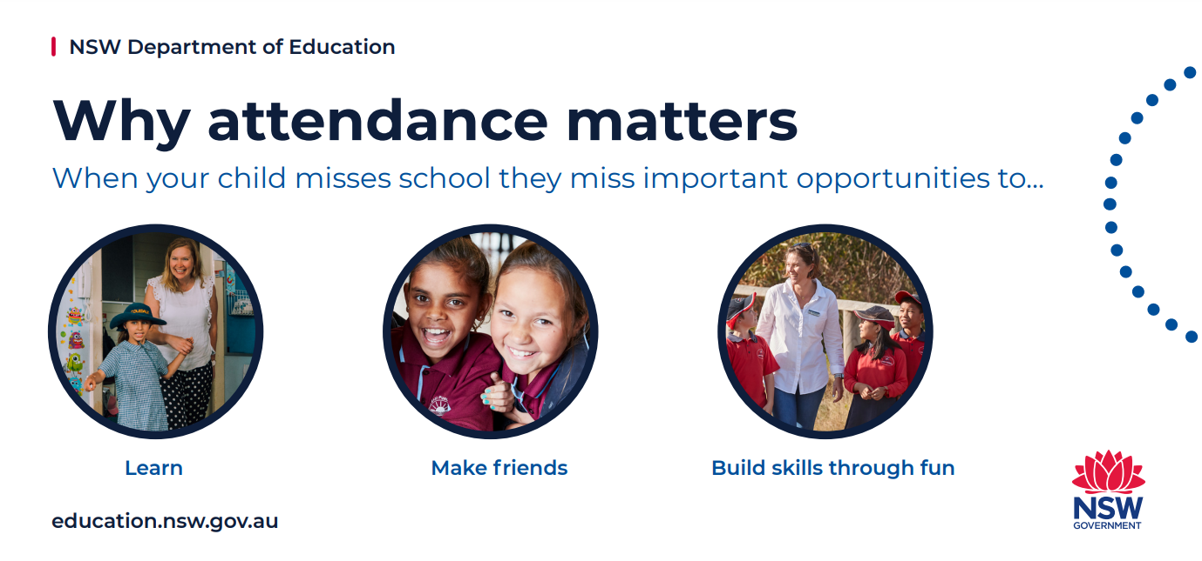

DEPUTY PRINCIPAL’S REPORT

Last week our Year 6 students underwent Peer Support training in preparation for Peer Support lessons beginning this Wednesday. This six-week program has Year 6 lead their small group of K-5 students through lessons about open mindedness, leadership, kindness and more. It’s a great opportunity for all our Year 6 students to step up and lead our younger students through this valuable program. All Year 6 have sat through this program previously, led by other students. Now it is their turn and I know they will do an excellent job!

Education for your child is important and regular attendance at school is essential for your child to achieve their educational best and increase their career and life options. NSW public schools work in partnership with parents to encourage and support regular attendance of children and young people. When your child attends school every day, learning becomes easier and your child will build and maintain friendships with other children.

Mrs Taylor

OFFICE REPORT

LATE ARRIVALS
The procedures for late arrivals remains unchanged. All late students should be reporting to the school office prior to going to class. The students will be given a late pass to hand to their teacher. Parents are not required to escort their child to the office.

Please note that the Earl Street gate is locked between 10:00am and 3:00pm.

ENTERING ABSENCES IN COMPASS
Sick/Other Leave
The only absences parents are to enter into Compass are full day absences for illness or other leave up to 3 days.

Extended Leave
Absences of 3 or more days for holidays, etc, parents are to complete an Extended Leave form which is located on the school’s website. This will be approved by the

Principal and a certificate for the leave will be forwarded to them.

Partial Leave
Late arrivals or early leavers are entered into Compass by the office staff only.

ENROLMENTS FOR KINDY 2023
Kindergarten enrolments for 2023 are starting to come in. You can enrol your child on-line via the school website.

If you are out of area, please pop into the office to pick up a Non Local form.

AWARDS

The following students have recently received their Silver Awards: Liam J 4H, Louis B 4B, Ally N 4H, Oscar K 2L, Gui M 4B, Rafael F 2P, Millie P 4B, Sophie F 5K, Poppy S 4H, Matilda B 2/3B, Riley A 6C Andrew A 4H, Knox N 4H, Stanley H 4B.

Congratulations to the following students for receiving their Gold Awards:

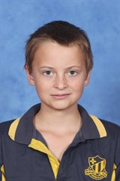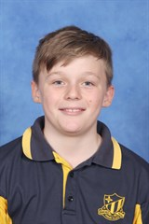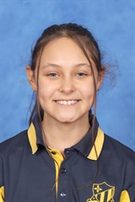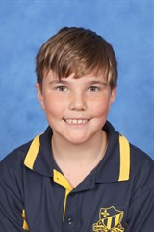

Cai R 5P Thomas D 6C Millie P 4B Gui M 4B

CREATIVE ARTS

Rehearsals are on as usual, except for Thursday morning Junior Choir rehearsal.

JUNIOR CHOIR
As previously notified via email, Junior Choir practice is cancelled this Thursday August 4, due to the clash with Senior Choir rehearsal for Ryde Schools’ Spectacular. An extended make-up rehearsal will be organised during school hours.

DRAMA ENSEMBLE
Congratulations to all our Drama Ensemble students in years 4, 5 and 6 who delivered a fabulous performance of their group devised item Smile to open the show on Tuesday evening at the Arts Alive Drama Festival at the Concourse Theatre, Chatswood. The Ensemble performed with energy, focus and professionalism and are be commended on both their excellent achievement and for representing our school with pride.

SENIOR CHOIR REMINDER
The next combined choir rehearsal for the Ryde Schools’ Spectacular is on this Thursday 4 August. Students are reminded to meet Mrs Nylund and Mrs Butler at the flagpole at 8:15am. We will be back at school by bell time.

BOYS’ DANCE CREW
Congratulations to our boys’ dance crew on their wonderful effort performing for the audition panel for the Ryde Schools’ Spectacular last Thursday. The boys are to be commended for their fabulous team spirit, energy and enthusiasm! Well done!

Mrs Nylund

DEBATING

The final round for the zone will see our two teams debate against each other. Parents are welcome to attend the debate, at 10:15am on Tuesday 2 August in the library. Visitors must sign in at the office using the QR code. The topic area for this debate is Health and Fitness.

Mrs Hunt, Mrs Mugglestone, Miss Kilmore

LIBRARY

Three weeks to go! The Premier’s Reading Challenge closes Friday 19 August. Please contact your classroom teacher for login and password details to enter in 30 books (K-2) or 20 books (3-6). So far, 401 Boronia Park students have completed their challenge. Congratulations to the following students on completing their Challenge last week:

Rueben K 1LP, Agnes C 1M, Layla H, Mia K 2L, Matias T 2/3B, Samuel D, Sophie K 3G, Dottie C, Michael R 3T, Sebastian P 4S, Leah H 5K.

Mrs Hunt

NSW PREMIER’S SPELLING BEE


Last week students in Stage 2 and 3 took part in spelling activities and an oral spelling bee within their classroom. Two students from each of these classes have progressed to the school spelling bee finals, which take place this Tuesday, 2 August.

Well done to the following finalists -

2/3B - Abigail W & Matias T
3G - Zane L & Aurora G
3T- Rishi P & Isabelle L
4B - Luella H & Rohan M
4H - Poppy S & Abby V
4S - Alexander C & Lachlan C
5A - Winnie W & Ella S
5K - Raphaela A & Keira G
5P - Charlie C & Leo H
6C - Alexandra H & Hamish PO
6L - Edwin C & Jonti E
6S - Max V & Hunter LY
Good luck to all these fabulous spellers!

Miss Kilmore

SCHOOL PHOTOGRAPHS


School photographs will be taken on 16, 17 and 18 August. All orders must be completed online via the school photographer website: www.theschoolphotographer.com.au
Using our school code:
X1669EL46B

Please note, sibling photographs must be ordered before Wednesday 17 August.

Students need to wear their full summer uniform: a short-sleeved school polo shirt and shorts, a skirt or a skort. All students are to wear blue socks and black shoes.

On Wednesday, PSSA students must come dressed in their full summer uniform and bring their summer and winter PSSA uniforms. Recorder and band students are welcome to bring their instruments on Wednesday for their group photographs. On Tuesday, string ensemble students may bring their instrument for their group photograph.

Mrs Mugglestone & Miss Liong

SPORT

K-6 ATHLETICS CARNIVAL
Our athletics carnival will take place on Monday 8 August at Dunbar Park Marsfield. Please be at school by 8:45am to help with transport via bus.


ATHLETICS CARNIVAL HELP REQUIRED
We are quite short of our usual numbers for parent volunteers. It is a great whole school community event and day. As a helper you can be almost part of the action! Carnivals can only run smoothly with the assistance of willing parent helpers on the day. The main jobs include: - timekeepers, course set up, judges and marshalling. If you can assist on the day, please email John and Elise McLachlan at: BPPSsports@outlook.com.au.
If you have not completed a Department of Education declaration form for Volunteer & Child-related services during your time at BPPS, or are unsure, please contact the school office to confirm.
IMPORTANT: There are to be NO dogs brought to the event with spectators.
Mr Smyth

P&C

P&C GENERAL MEETING - TONIGHT @7:30PM IN LIBRARY OR JOIN VIA ZOOM
We’re halfway through the school year with spring peeking its warm face around the corner. The P&C has had a busy year with lots of exciting plans to come! It was so great to see many new (and old!) faces at the fantastic Parents Night. The P&C look forward to getting to know you better and (hopefully!) involved in this vibrant school community.

Our 5th General P&C meeting will be on tonight @ 7:30pm in the library or online (Zoom). We will be hearing from the principal and required committee reports. This will include updates & news on our busy social calendar and upcoming events.

Other items for discussion include:

- Update/progress on BPCC request to roll under P&C
- Aftercare capacity & options including Tennis World
- Executive committee roles & future planning
Please join us in the school library @7:30pm in person or via Zoom link below.
Boronia Park Public School P&C general meeting #5 - 1/8/2022
Meeting ID: 620 6267 0909
Passcode: 123456
Check also our Facebook page Boronia Park Public School Community Group for the agenda & Zoom link.
BPPS P&C Team

THANK YOU FOR YOUR SUPPORT THIS YEAR TOWARDS OUR $100K FUNDRAISING GOAL!
Parents Night was an absolute blast! What a great way to bring the community back together again. There was definitely more than a touch of sparkle and there were some seriously funky moves on the dancefloor too. It was fantastic to see some of the staff there, including Mrs Ward and Mrs Hunt who both helped to auction off their jobs for a day. What a terrific night, and a terrific result for our fundraising efforts too. Thank you!

We are now closer towards our fundraising target so we can upgrade the school library and continue to provide vital learning support to the children. So far we have raised $37,500, which includes $14,755 from our Parents Night on Saturday. We still have a wide range of items available on our online auction - some big, some small - and items start at 50% RRP. Bidding closes at 7:00pm on Friday 5 August - go to www.32auctions.com/BPPS2022

Thank you and keep an eye out for messaging about Father's Day this week as we will be kicking off the Flexischools ordering ASAP.

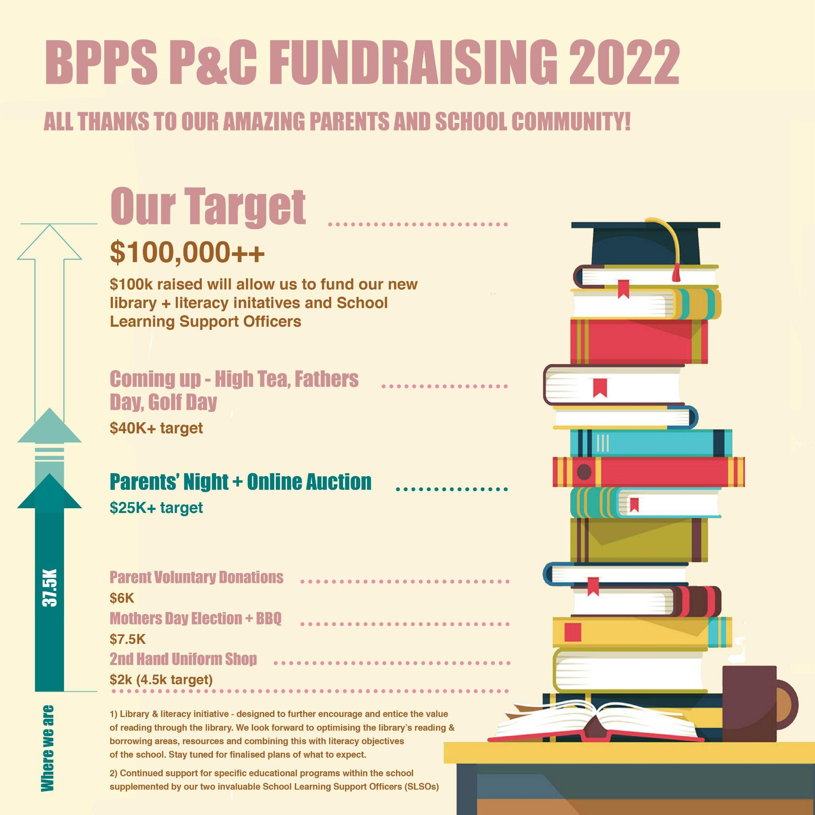

P&C Fundraising Team

CANTEEN

Mondays: Sushi $3.70
Tuesdays: Roast chicken rolls $5.00
Salad boxes with chicken $5.50

Wednesdays: Chicken and beef burgers


Thursdays: Sushi $3.70
This Photo by Unknown Author is licensed under CC BY

BUSY CANTEEN –

HELP DESPERATELY NEEDED

The canteen continues to get busier and we need your help!

The new roster for Term 3 is now open. Along with our usual shifts, we’ve introduced new half day shifts on Thursdays and Fridays to help manage the lunch time rush. There are also Friday afternoon iceblock sales shifts available.

To make it easier for our volunteers the canteen roster is now online. If you know you have a free day coming up, jump online and add yourself to the roster.

The roster can be found at or by scanning the QR code: https://signup.com/go/huwfTkq



This Photo by Unknown Author is licensed under CC BY-SA-NC

FRIDAY AFTERNOONS

The canteen is open on Friday afternoons from 3:20pm. Come by to get your end of week treats.

FRESH 4 KIDS – EAT FRESH & WIN 2022

The Eat Fresh and Win campaign is back for 2022. Commencing Monday 1 August and ending Friday 16 September 2022, each time a student makes a healthy selection from the canteen (fruit and/or vegetables), they are rewarded with a stamp on their entry form. Collect 2 stamps and you will receive a minor prize and go into the major prize draw.

ATHLETICS CARNIVAL MONDAY 8 AUGUST


The canteen will be operating at the athletics carnival. We will be serving pies and sausage rolls, wraps and rolls with assorted fillings, snacks and drinks, tea and coffee.

Please note, cash purchases only and no pre-ordering.


FISH & CHIPS DAY TUESDAY 16 AUGUST

Enjoy delicious Fish and Chips on Tuesday 16 August. Orders can be placed via Flexischools or paper order forms are available from the canteen. Order now or before Friday 12 August. Help required please.

FISH & CHIPS
Tuesday 16 August 2022
ORDER FORM

Enjoy delicious Fish and Chips with your choice of tomato, BBQ or tartare sauce $5. Add a drink for $2.00.

All orders must be received by 10:00am
Friday 12 August 2022.
**No orders will be taken on the day**

Child’s Name _______________________________

Class: _____________

□ Fish & Chips $5.00
□ Tomato/BBQ/tartare sauce/no sauce
□ Glee/juice,/straw milk/choc milk/water $2.00
(Please circle your sauce and drink choice)

PROJECT KINDNESS
FOOD & BLANKET DRIVE



